MT: The main advantages of modern tracking programs for vehicles
MD: The modern tracking software will keep you informed and reduce your stress level. Click the link and find out more about the advantages of tracking.
<h1>Use tracking program and forget about stress</h1>
It is an open secret that nowadays life goes faster and faster. Daily routine, deadlines, schedules and other things make it completely stressful. Especially it concerns businessmen, because they have a lot of stuff to manage, control the work of the company and employees. But with the development of engineering industries people try to ease their job and make it more productive in all spheres of our life.
Some may say that it is impossible to keep an eye on everything and everybody especially on long distances. It is not so. There are a lot of devices that track the data and location of vehicles, their work, time on the route, etc. Moreover, it is not expensive. Some companies develop tracking apps for smartphones and tablets. For example, use Uboro software if you want to try it out and organize your company.
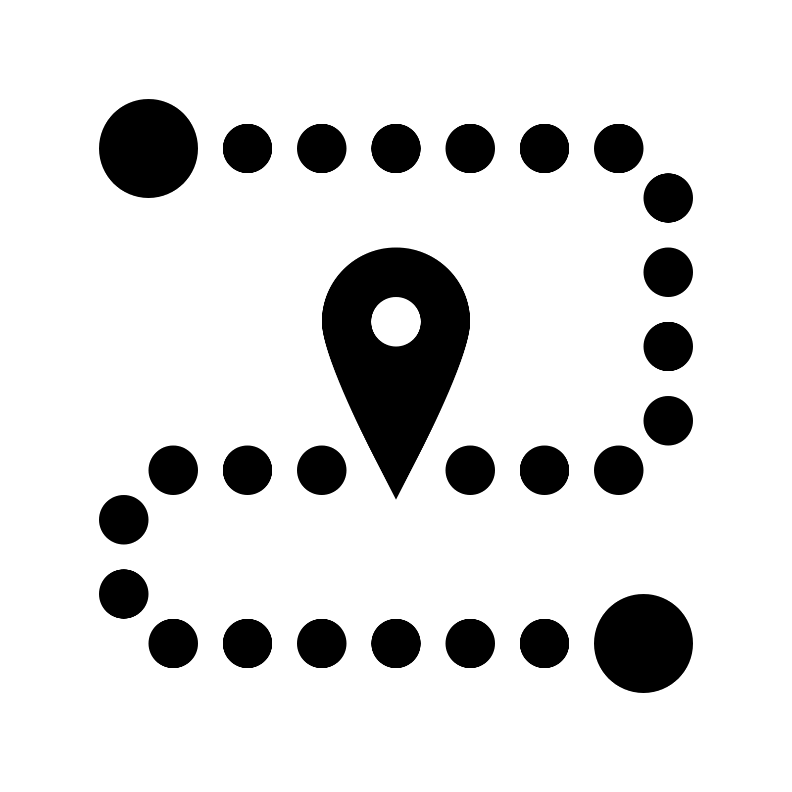
[https://png.icons8.com/track-order/win10/1600]
<h2>Tracking will manage everything</h2>

For better detailed understanding how the tracking works itself, let us point out some advantages of using such software:
- Tracking vehicles.
Observe where a car is, where it is going or how long the driver is on the route. Besides, drivers have an access to the information about traffic, the quality of roads, etc.
- Optimize the work.
A lot of tracking devices show you the information about the car, fuel consumption and whether a driver has forgotten to turn down the engine. Also it displays drivers’ behavior on the road, rules violations.
- Less stress.
No need to call, ask or worry about your vehicles – just open a software and watch.
- Fast tracking.
It works without any delays and shows you up-to-date information, which gives an opportunity to monitor almost in a real time.
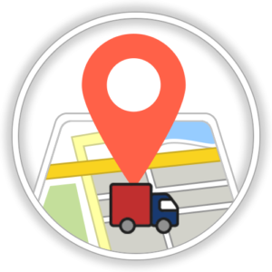
[https://fibicosmetics.com/en/files/2016/11/Tracking-Icon-300x300.png]
- User-friendly.
It does not need any special knowledge or education. There is an intuitive interface and instructions which will help you to get used to it.
- Fuel consumption control.
It is a great protection from thefts and frauds which can save your money.
- Working process.
Control all arrivals or departures of the goods and identify objects, their location, time and status.
- Excellent functional and design.
These things have more than just tracking. They present a lot of options presented with an attractive pictures.
- Updating.
Companies ask their customers for a feedback to find out what aspects work good or what they should change or develop.
- Marking.
You can add marks or points on the route that may be important for drivers.
As you see, tracking programs are completely useful. They work to make you feel comfortable. Companies guarantee reliability, long-term exploitation and technical support in all questions concerning the work. Try it and make your life easier and happier.

